Lab Plan Week – 6

- Create an application that has Icon button with toggle Icon that changes the theme of your application as dark or light theme. Create the button on the App bar.
Hint: Use ternary Operator
Code:
import 'package:flutter/material.dart';

void main() {
runApp(const MyApp());
}

class MyApp extends StatefulWidget {
const MyApp({super.key});

@override
State<MyApp> createState() => _MyAppState();
}

class _MyAppState extends State<MyApp> {
bool _isDarkMode = false;

void _toggleTheme() {
setState(() {
_isDarkMode = !_isDarkMode;
});
}

@override
Widget build(BuildContext context) {
return MaterialApp(
title: 'Flutter Themes',
debugShowCheckedModeBanner: false,
// Ternary operator to switch between dark and light theme
themeMode: _isDarkMode ? ThemeMode.dark : ThemeMode.light,
theme: ThemeData(
brightness: Brightness.light,
colorSchemeSeed: Colors.blue,
useMaterial3: true,
),
darkTheme: ThemeData(
brightness: Brightness.dark,
colorSchemeSeed: Colors.blue,
useMaterial3: true,
),
home: HomeScreen(isDarkMode: _isDarkMode, onToggle: _toggleTheme),
);
}
}

class HomeScreen extends StatelessWidget {
final bool isDarkMode;
final VoidCallback onToggle;

const HomeScreen({
super.key,
required this.isDarkMode,
required this.onToggle,
});

@override
Widget build(BuildContext context) {
return Scaffold(
appBar: AppBar(
title: const Text('Flutter Themes'),
actions: [
// Toggle icon button using ternary operator
IconButton(
icon: Icon(isDarkMode ? Icons.dark_mode : Icons.light_mode),
tooltip: isDarkMode ? 'Switch to Light' : 'Switch to Dark',
onPressed: onToggle,
),
],
),
body: const Center(
child: Text('Toggle the icon on the AppBar to switch theme!'),
),
);
}
}

Output Screenshot:
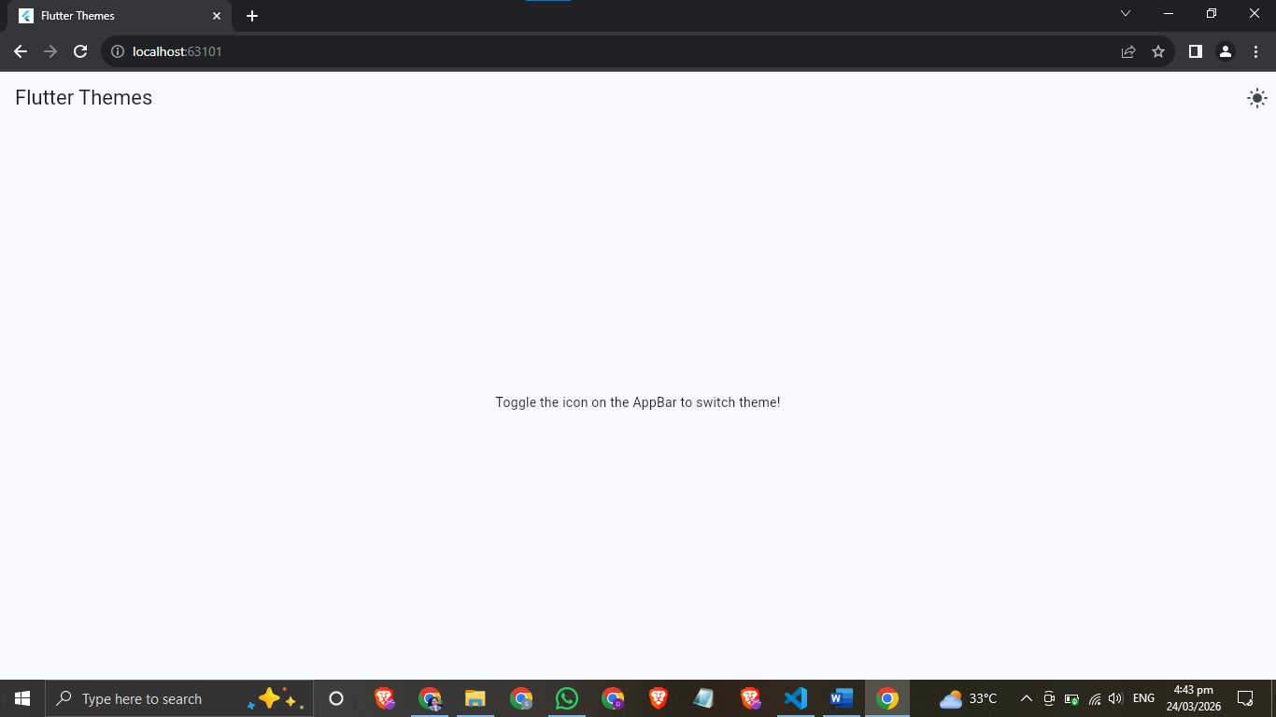
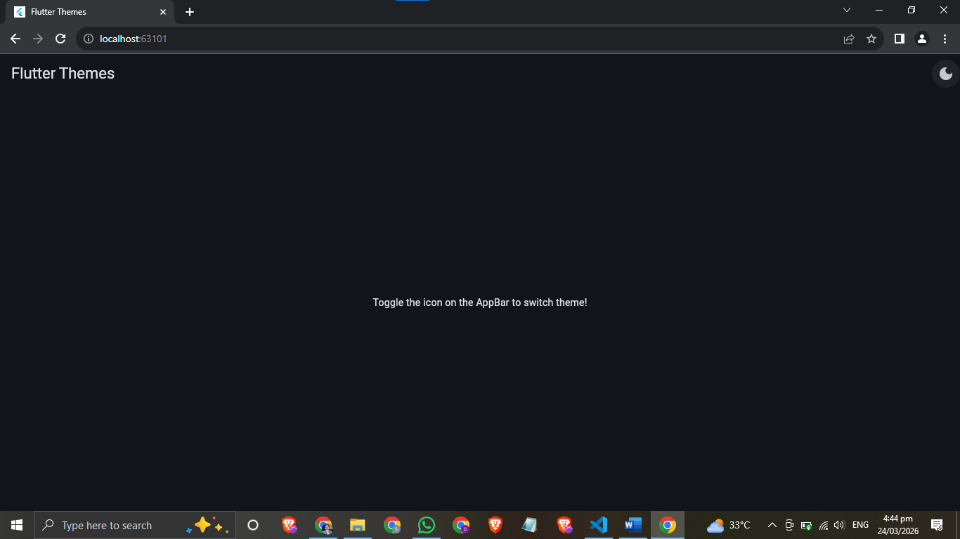

- Add some paragraphs of text on the screen and use the theme data class to implement the textTheme properties like font style, font size, and colors on the text.

Code:

import 'package:flutter/material.dart';

void main() {
runApp(const MyApp());
}

class MyApp extends StatefulWidget {
const MyApp({super.key});

@override
State<MyApp> createState() => _MyAppState();
}

class _MyAppState extends State<MyApp> {
bool _isDarkMode = false;

void _toggleTheme() {
setState(() {
_isDarkMode = !_isDarkMode;
});
}

@override
Widget build(BuildContext context) {
return MaterialApp(
title: 'Flutter Themes',
debugShowCheckedModeBanner: false,
themeMode: _isDarkMode ? ThemeMode.dark : ThemeMode.light,

// ── Light Theme with custom TextTheme ──
theme: ThemeData(
brightness: Brightness.light,
colorSchemeSeed: Colors.blue,
useMaterial3: true,
textTheme: const TextTheme(
// Used for big headings
displayLarge: TextStyle(
fontSize: 32,
fontWeight: FontWeight.bold,
color: Colors.blue,
fontStyle: FontStyle.normal,
),
// Used for section titles
titleLarge: TextStyle(
fontSize: 22,
fontWeight: FontWeight.w700,
color: Colors.indigo,
fontStyle: FontStyle.italic,
),
// Used for body paragraphs
bodyLarge: TextStyle(
fontSize: 16,
fontWeight: FontWeight.normal,
color: Colors.black87,
height: 1.6,
),
// Used for captions / small text
bodySmall: TextStyle(
fontSize: 12,
fontWeight: FontWeight.w300,
color: Colors.grey,
fontStyle: FontStyle.italic,
),
),
),

// ── Dark Theme with custom TextTheme ──
darkTheme: ThemeData(
brightness: Brightness.dark,
colorSchemeSeed: Colors.blue,
useMaterial3: true,
textTheme: const TextTheme(
displayLarge: TextStyle(
fontSize: 32,
fontWeight: FontWeight.bold,
color: Colors.lightBlueAccent,
fontStyle: FontStyle.normal,
),
titleLarge: TextStyle(
fontSize: 22,
fontWeight: FontWeight.w700,
color: Colors.tealAccent,
fontStyle: FontStyle.italic,
),
bodyLarge: TextStyle(
fontSize: 16,
fontWeight: FontWeight.normal,
color: Colors.white70,
height: 1.6,
),
bodySmall: TextStyle(
fontSize: 12,
fontWeight: FontWeight.w300,
color: Colors.white38,
fontStyle: FontStyle.italic,
),
),
),

home: HomeScreen(isDarkMode: _isDarkMode, onToggle: _toggleTheme),
);
}
}

class HomeScreen extends StatelessWidget {
final bool isDarkMode;
final VoidCallback onToggle;

const HomeScreen({
super.key,
required this.isDarkMode,
required this.onToggle,
});

@override
Widget build(BuildContext context) {
final textTheme = Theme.of(context).textTheme;

return Scaffold(
appBar: AppBar(
title: const Text('Flutter Themes'),
actions: [
IconButton(
icon: Icon(isDarkMode ? Icons.dark_mode : Icons.light_mode),
tooltip: isDarkMode ? 'Switch to Light' : 'Switch to Dark',
onPressed: onToggle,
),
],
),
body: SingleChildScrollView(
padding: const EdgeInsets.all(20),
child: Column(
crossAxisAlignment: CrossAxisAlignment.start,
children: [
// displayLarge — big heading
Text('Welcome to NTU', style: textTheme.displayLarge),
const SizedBox(height: 12),

// titleLarge — section title
Text('Who are You?', style: textTheme.titleLarge),
const SizedBox(height: 8),

// bodyLarge — paragraph
Text(
'Hi there Myself Dawood Saif Cheema'
'I am a Aspiring Devops/ Cloud Engineer '
'Right Now I am doing Beachelor in Software Engineering ',
style: textTheme.bodyLarge,
),
const SizedBox(height: 20),

Text('Whats your age and birth place?', style: textTheme.titleLarge),
const SizedBox(height: 8),

Text(
'Hi there Myself Dawood Saif Cheema'
'I am 20 Year old '
'and I was born in Faisalabad Pakistan',
style: textTheme.bodyLarge,
),
const SizedBox(height: 20),

Text('Your Intersts ', style: textTheme.titleLarge),
const SizedBox(height: 8),

Text(
'Hi there Myself Dawood Saif Cheema'
'My Intersts are Politics, Sports , Business and Technology',
style: textTheme.bodyLarge,
),
const SizedBox(height: 16),

// bodySmall — caption
Text(
'* All text styles are applied using ThemeData textTheme properties.',
style: textTheme.bodySmall,
),
],
),
),
);
}
}

Output Screenshot:

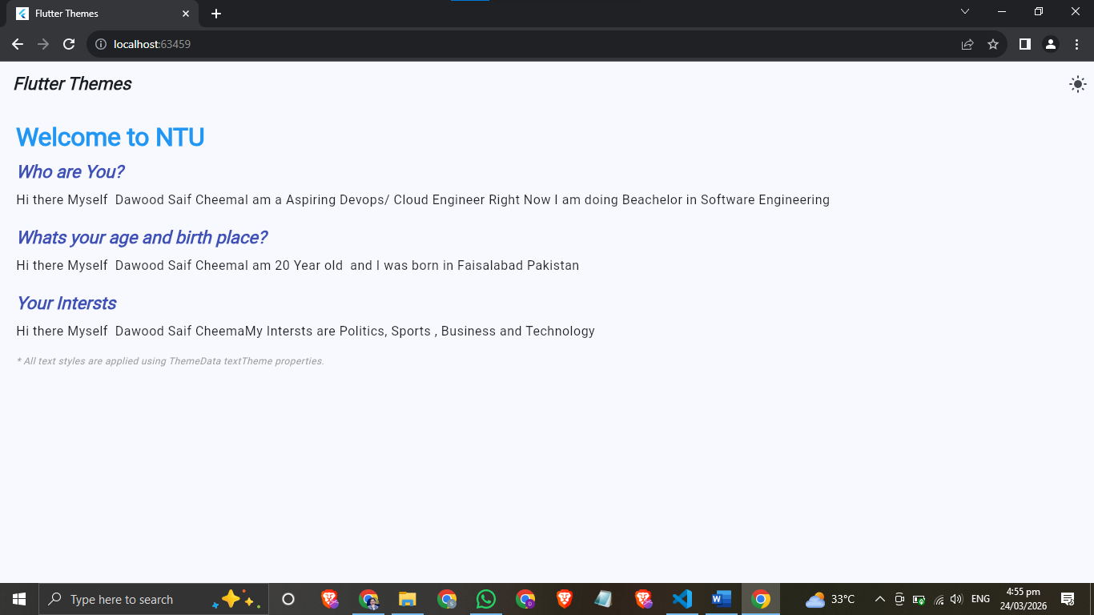
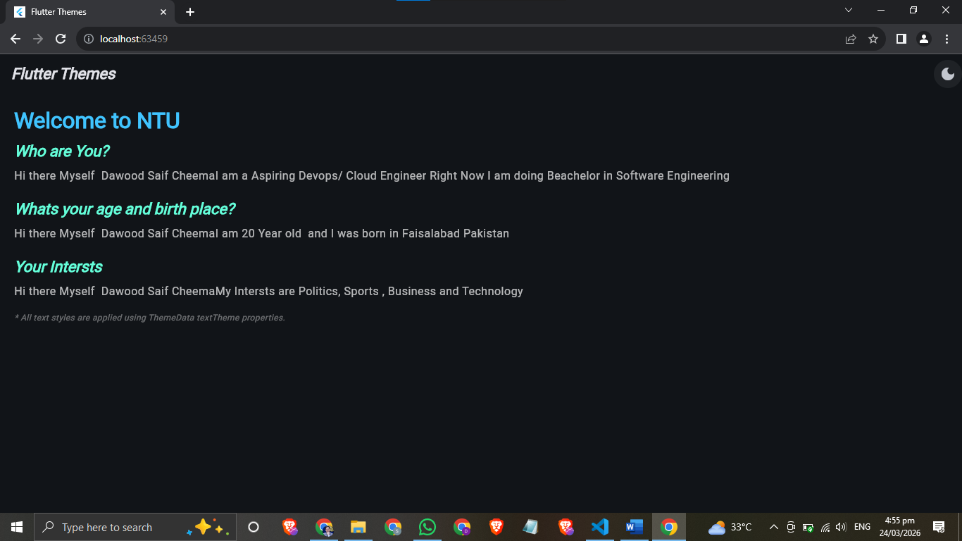

- Apply Themes on cards, buttons and App bar.
Code:
import 'package:flutter/material.dart';

void main() {
runApp(const MyApp());
}

class MyApp extends StatefulWidget {
const MyApp({super.key});

@override
State<MyApp> createState() => _MyAppState();
}

class _MyAppState extends State<MyApp> {
bool _isDarkMode = false;

void _toggleTheme() {
setState(() {
_isDarkMode = !_isDarkMode;
});
}

@override
Widget build(BuildContext context) {
return MaterialApp(
title: 'Flutter Themes',
debugShowCheckedModeBanner: false,
themeMode: _isDarkMode ? ThemeMode.dark : ThemeMode.light,

// ── Light Theme ──
theme: ThemeData(
brightness: Brightness.light,
colorSchemeSeed: Colors.blue,
useMaterial3: true,

textTheme: const TextTheme(
displayLarge: TextStyle(fontSize: 30, fontWeight: FontWeight.bold, color: Colors.blue),
titleLarge: TextStyle(fontSize: 20, fontWeight: FontWeight.w700, color: Colors.indigo, fontStyle: FontStyle.italic),
bodyLarge: TextStyle(fontSize: 15, color: Colors.black87, height: 1.6),
bodySmall: TextStyle(fontSize: 12, color: Colors.grey, fontStyle: FontStyle.italic),
),

appBarTheme: const AppBarTheme(
backgroundColor: Colors.blue,
foregroundColor: Colors.white,
centerTitle: true,
elevation: 4,
titleTextStyle: TextStyle(fontSize: 20, fontWeight: FontWeight.bold, color: Colors.white),
),

elevatedButtonTheme: ElevatedButtonThemeData(
style: ElevatedButton.styleFrom(
backgroundColor: Colors.blue,
foregroundColor: Colors.white,
textStyle: const TextStyle(fontSize: 16, fontWeight: FontWeight.bold),
padding: const EdgeInsets.symmetric(horizontal: 24, vertical: 12),
shape: RoundedRectangleBorder(borderRadius: BorderRadius.circular(10)),
),
),

outlinedButtonTheme: OutlinedButtonThemeData(
style: OutlinedButton.styleFrom(
foregroundColor: Colors.blue,
side: const BorderSide(color: Colors.blue, width: 2),
textStyle: const TextStyle(fontSize: 15, fontWeight: FontWeight.w600),
padding: const EdgeInsets.symmetric(horizontal: 20, vertical: 10),
shape: RoundedRectangleBorder(borderRadius: BorderRadius.circular(10)),
),
),

textButtonTheme: TextButtonThemeData(
style: TextButton.styleFrom(
foregroundColor: Colors.indigo,
textStyle: const TextStyle(
fontSize: 15,
fontWeight: FontWeight.w600,
decoration: TextDecoration.underline,
),
),
),
),

// ── Dark Theme ──
darkTheme: ThemeData(
brightness: Brightness.dark,
colorSchemeSeed: Colors.blue,
useMaterial3: true,

textTheme: const TextTheme(
displayLarge: TextStyle(fontSize: 30, fontWeight: FontWeight.bold, color: Colors.lightBlueAccent),
titleLarge: TextStyle(fontSize: 20, fontWeight: FontWeight.w700, color: Colors.tealAccent, fontStyle: FontStyle.italic),
bodyLarge: TextStyle(fontSize: 15, color: Colors.white70, height: 1.6),
bodySmall: TextStyle(fontSize: 12, color: Colors.white38, fontStyle: FontStyle.italic),
),

appBarTheme: const AppBarTheme(
backgroundColor: Color(0xFF1A1A2E),
foregroundColor: Colors.lightBlueAccent,
centerTitle: true,
elevation: 4,
titleTextStyle: TextStyle(fontSize: 20, fontWeight: FontWeight.bold, color: Colors.lightBlueAccent),
),

elevatedButtonTheme: ElevatedButtonThemeData(
style: ElevatedButton.styleFrom(
backgroundColor: Colors.tealAccent,
foregroundColor: Colors.black,
textStyle: const TextStyle(fontSize: 16, fontWeight: FontWeight.bold),
padding: const EdgeInsets.symmetric(horizontal: 24, vertical: 12),
shape: RoundedRectangleBorder(borderRadius: BorderRadius.circular(10)),
),
),

outlinedButtonTheme: OutlinedButtonThemeData(
style: OutlinedButton.styleFrom(
foregroundColor: Colors.tealAccent,
side: const BorderSide(color: Colors.tealAccent, width: 2),
textStyle: const TextStyle(fontSize: 15, fontWeight: FontWeight.w600),
padding: const EdgeInsets.symmetric(horizontal: 20, vertical: 10),
shape: RoundedRectangleBorder(borderRadius: BorderRadius.circular(10)),
),
),

textButtonTheme: TextButtonThemeData(
style: TextButton.styleFrom(
foregroundColor: Colors.lightBlueAccent,
textStyle: const TextStyle(
fontSize: 15,
fontWeight: FontWeight.w600,
decoration: TextDecoration.underline,
),
),
),
),

home: HomeScreen(isDarkMode: _isDarkMode, onToggle: _toggleTheme),
);
}
}

class HomeScreen extends StatelessWidget {
final bool isDarkMode;
final VoidCallback onToggle;

const HomeScreen({
super.key,
required this.isDarkMode,
required this.onToggle,
});

@override
Widget build(BuildContext context) {
final textTheme = Theme.of(context).textTheme;

// Card decoration pulled from theme colors manually
final cardColor = isDarkMode
? const Color(0xFF1E1E2E)
: Colors.blue.shade50;

return Scaffold(
appBar: AppBar(
title: const Text('Flutter Themes'),
actions: [
IconButton(
icon: Icon(isDarkMode ? Icons.dark_mode : Icons.light_mode),
tooltip: isDarkMode ? 'Switch to Light' : 'Switch to Dark',
onPressed: onToggle,
),
],
),
body: SingleChildScrollView(
padding: const EdgeInsets.all(20),
child: Column(
crossAxisAlignment: CrossAxisAlignment.start,
children: [

// ── Text Section ──
Text('Welcome to NTU', style: textTheme.displayLarge),
const SizedBox(height: 10),
Text('Whats your age and place of birth?', style: textTheme.titleLarge),
const SizedBox(height: 6),
Text(
'Hi there Myself Dawood Saif Cheema'
'I am 20 Year old '
'and I was born in Faisalabad Pakistan',
style: textTheme.bodyLarge,
),
const SizedBox(height: 16),
Text('Your Interests', style: textTheme.titleLarge),
const SizedBox(height: 6),
Text(
'Hi there Myself Dawood Saif Cheema\n'
'My Intersts are Politics, Sports , Business and Technology',
style: textTheme.bodyLarge,
),
const SizedBox(height: 4),
Text('* Styles applied via ThemeData textTheme.', style: textTheme.bodySmall),

const SizedBox(height: 24),

// ── Cards Section ──
Text('Themed Cards', style: textTheme.titleLarge),
const SizedBox(height: 8),

// Cards styled manually to avoid CardTheme version issues
_styledCard(
color: cardColor,
child: ListTile(
leading: const Icon(Icons.phone_android),
title: Text('Mobile Development', style: textTheme.bodyLarge),
subtitle: Text('Build Android & iOS apps', style: textTheme.bodySmall),
),
),
const SizedBox(height: 8),
_styledCard(
color: cardColor,
child: ListTile(
leading: const Icon(Icons.web),
title: Text('Web Development', style: textTheme.bodyLarge),
subtitle: Text('Deploy to Chrome and Edge', style: textTheme.bodySmall),
),
),
const SizedBox(height: 8),
_styledCard(
color: cardColor,
child: ListTile(
leading: const Icon(Icons.desktop_windows),
title: Text('Desktop Development', style: textTheme.bodyLarge),
subtitle: Text('Windows, macOS & Linux', style: textTheme.bodySmall),
),
),

const SizedBox(height: 24),

// ── Buttons Section ──
Text('Themed Buttons', style: textTheme.titleLarge),
const SizedBox(height: 12),

Row(
mainAxisAlignment: MainAxisAlignment.spaceEvenly,
children: [
ElevatedButton(
onPressed: () {},
child: const Text('Elevated'),
),
OutlinedButton(
onPressed: () {},
child: const Text('Outlined'),
),
TextButton(
onPressed: () {},
child: const Text('Text'),
),
],
),

const SizedBox(height: 20),
],
),
),
);
}

// Helper widget to style cards without CardTheme
Widget _styledCard({required Color color, required Widget child}) {
return Container(
decoration: BoxDecoration(
color: color,
borderRadius: BorderRadius.circular(12),
boxShadow: [
BoxShadow(
color: Colors.black.withOpacity(0.1),
blurRadius: 4,
offset: const Offset(0, 2),
),
],
),
child: child,
);
}
}

Output Screenshot:
